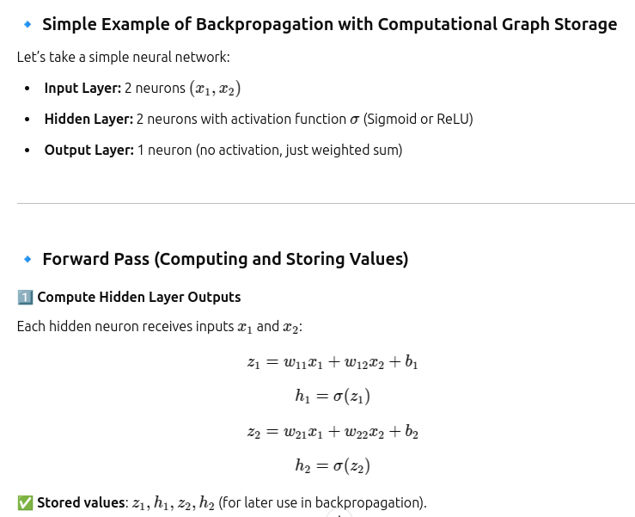
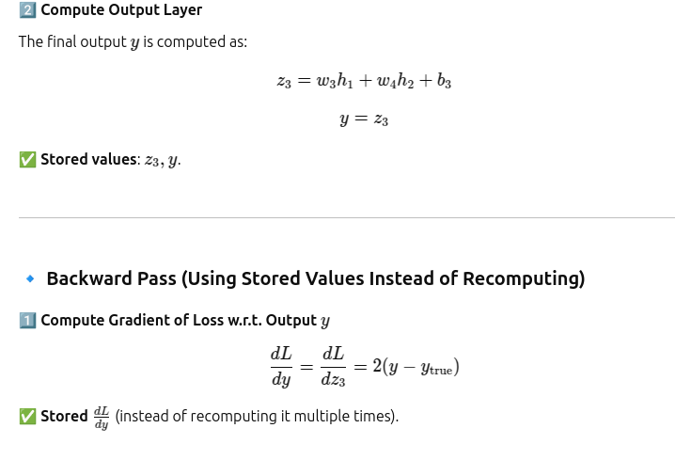
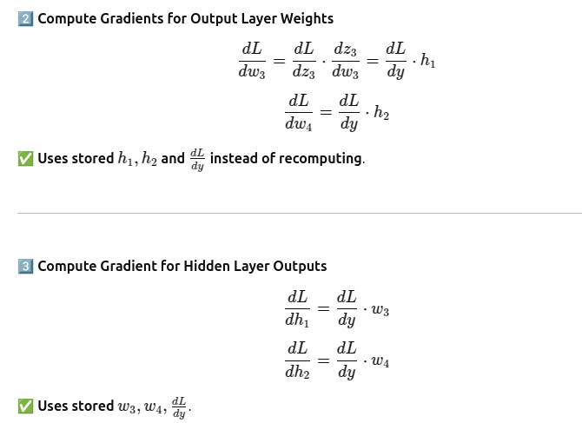
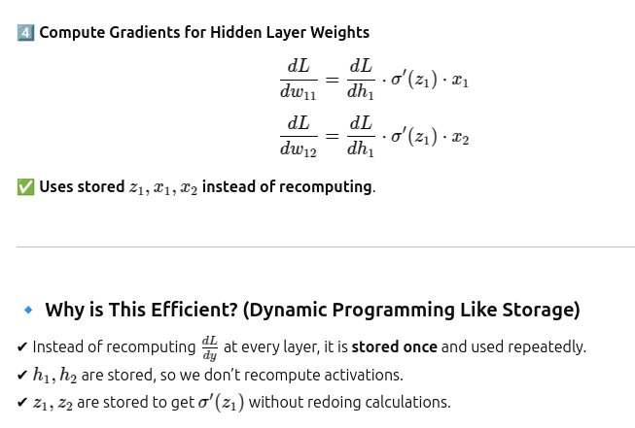
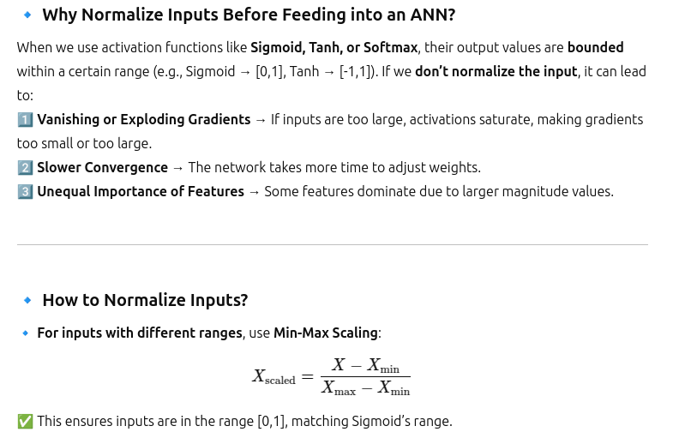
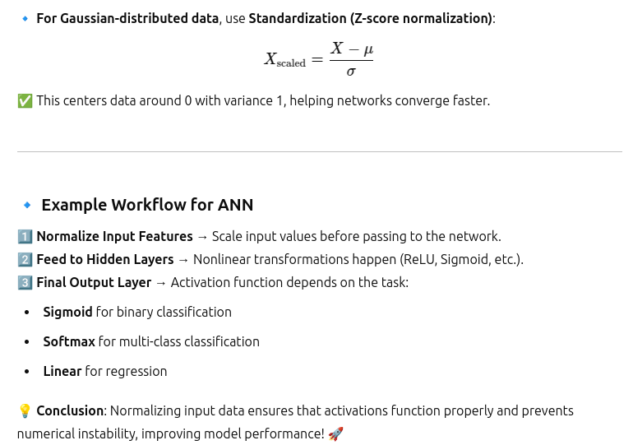

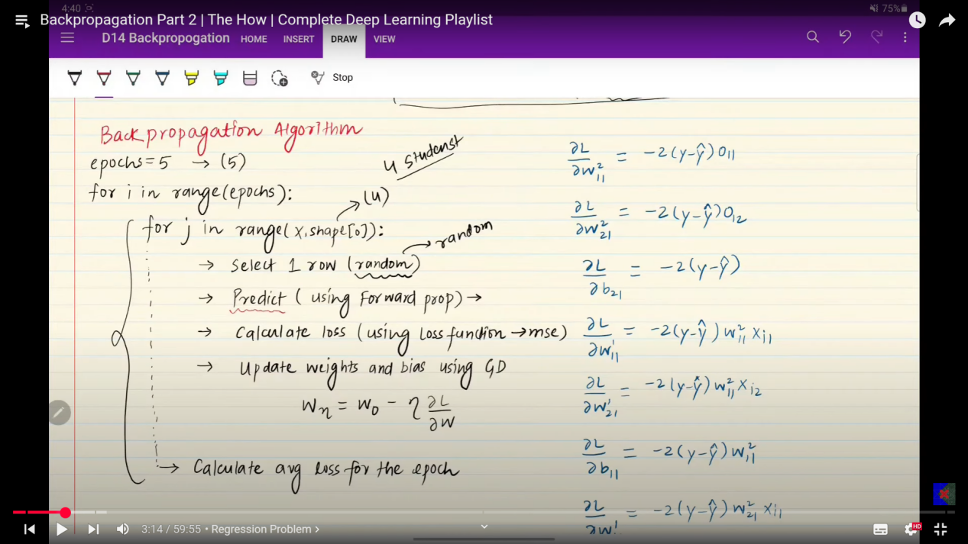

Why Back-Propagation Algorithm gives correct output?
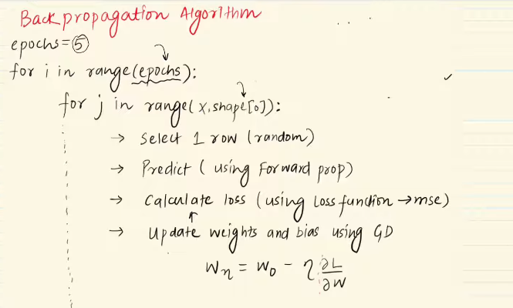
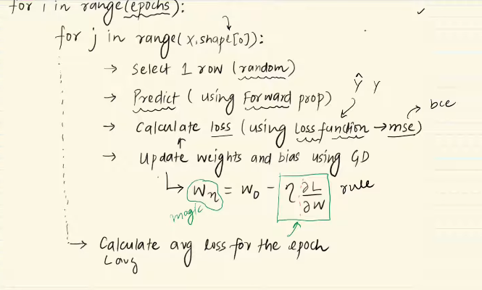
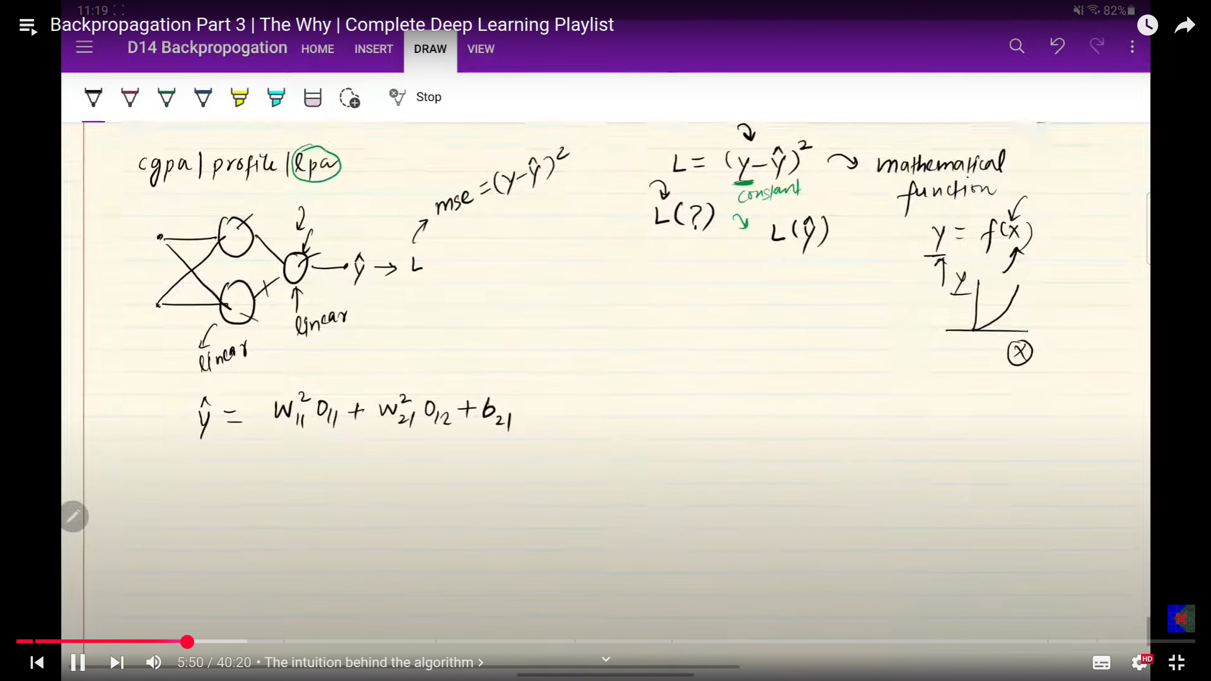
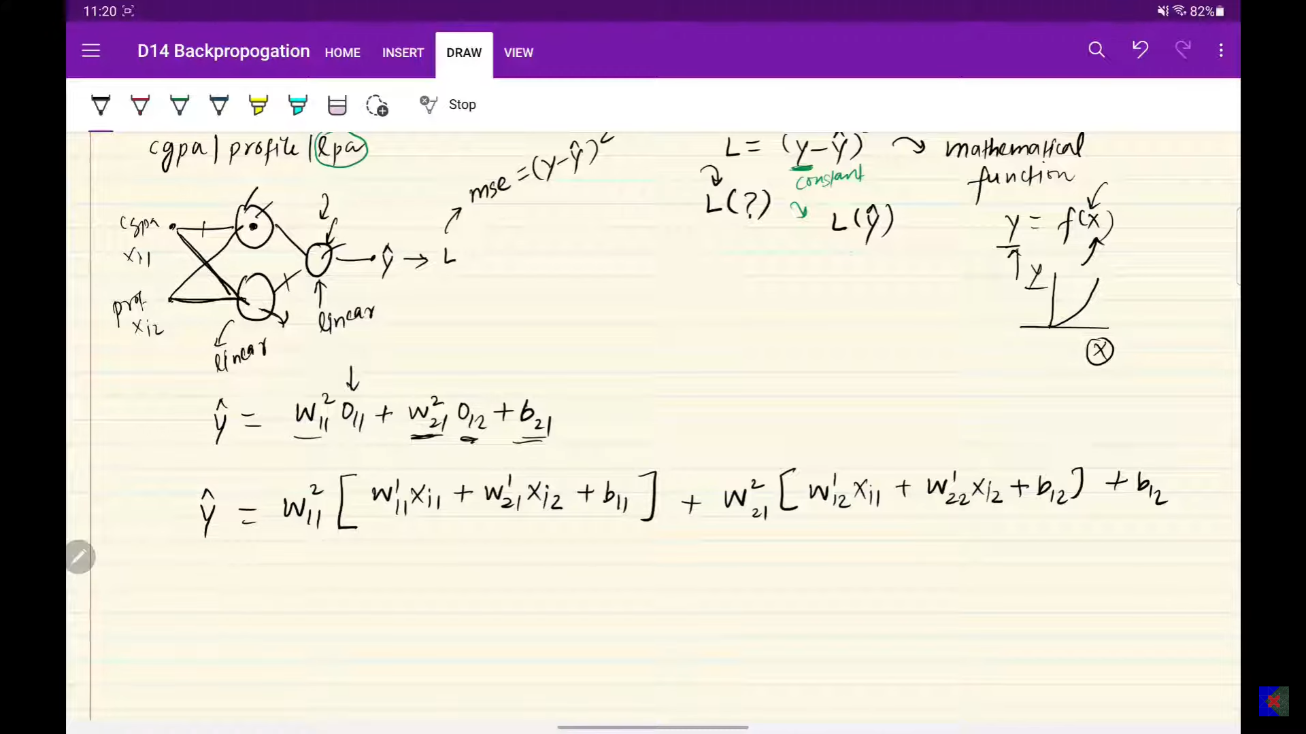
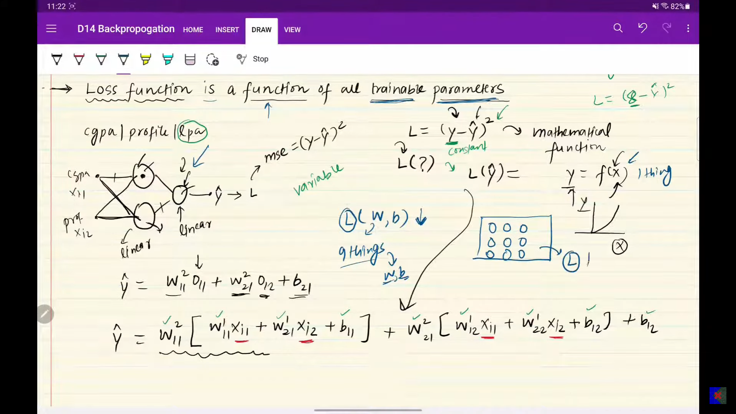
There are 9 trainable parameters with respect to the loss function.
Even if one of the parameters is tuned, then the whole loss function is changed. So by tuning which of the parameter will reduce the loss function.
Derivative is possible only when there is only one dependency is present.
Gradient(Partial derivative): This is used when a function have many deoendencies but need t take the derivative on more than one dependencies in those siutation the partialm deivatives s the only wqay that is nothing but the gradients.
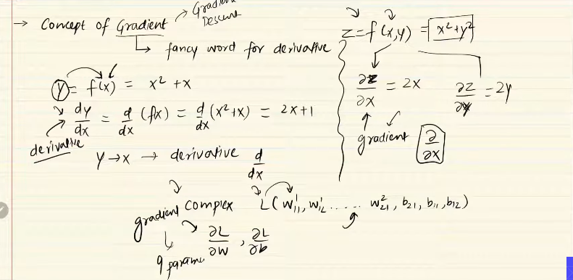

derivative
dy/dx - y is function of x.
y is dependent on x.
By changing x, we can see change in y. (dy/dx).
Magnitude and sign matters.
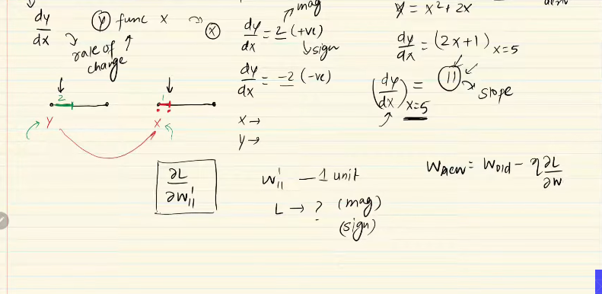
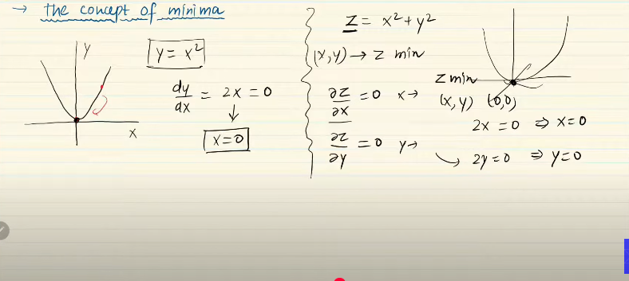
While taing the gradeint of one variable we make the many other dependent variables to constant. The rest everything are not considered to be the constants.

MLP MEMOIZATION
